Go to the following website:
http://www.phschool.com/science/biology_place/biocoach/cellresp/overview.html

Concept 1: Overview of Respiration
Click on the ‘Practice’ link at the top right corner of the page.
Label the diagram and fill your answers into the spaces below.

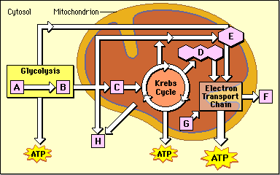
A.

B.

C.

D.

E.

F.

G.

Concept 2: Glycolysis
In glycolysis, the 6-carbon sugar, glucose, is broken down into two molecules of a 3-carbon molecule called pyruvate. This change is accompanied by a net gain of 2 ATP molecules and 2 NADH molecules.
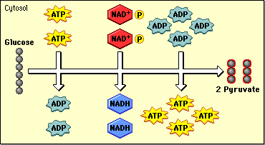
Click on REVIEW in the top right corner of the
page.

What are the 4 important stages in glycolysis?
1.

2.

3.

4.

As you go through the review, what do you notice about the overall input of energy, compared to the overall output?

Concept 3: Kreb’s cycle
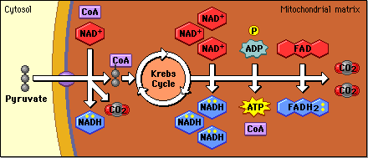
The Krebs cycle occurs in the mitochondrial matrix and generates a pool of chemical energy (ATP, NADH, and FADH₂) from the oxidation of pyruvate, the end product of glycolysis.
Pyruvate is transported into the mitochondria and loses carbon dioxide to form acetyl-CoA, a 2- carbon molecule. When acetyl-CoA is oxidized to carbon dioxide in the Krebs cycle, chemical energy is released and captured in the form of NADH, FADH₂, and ATP.

Click on the REVIEW button at the top right of the page. In the first animation, where does the pyruvate travel for the next step of respiration? ________________________

In the second animation, which compound actually enters the Kreb’s cycle? ______________________

What is another name for citric acid? ____________________

What is the overall input for the Kreb’s cycle? ______ CoA + ________ NAD⁺ + _______ GDP + ________P + ___________ FAD⁺

What is the overall output for the Kreb’s cycle? _________ CO₂ + _________ NADH + ________CoA + __________ ATP + __________ GDP + ________ FADH₂

Oxidative phosphorylation via the electron transport chain
The electron transport chain allows the release of the large amount of chemical energy stored in reduced NAD⁺ (NADH) and reduced FAD (FADH₂). The energy released is captured in the form of ATP (_______ ATP per NADH and ________ ATP per FADH₂).

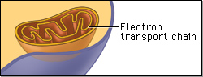
Where, specifically, does the electron transport chain occur
in the mitochondria? _________________________________

Click on “A Closer Look” at the top right corner.

The molecules in the electron transport chain are viewed as four _______________. Which molecule in the electron transport chain is responsible for chemiosmosis? ____________________________
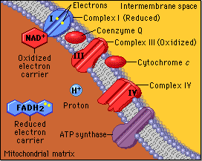
During the electron transport process, where are the hydrogen ions pumped? ____________________________

Click on the “Review” section at the top right corner of the page. Go through the animations, step by step.

What happens to the energy level of the electrons as they are passed from compound to compound in the ETC?

What happens to the energy level of the hydrogen ion (H⁺) gradient as the electrons are passed from molecule to molecule?

Click on the “Practice” section at the top right corner of the page.

Which molecule will first donate electrons to the electron transport chain? _______________

At the end of the electron transport chain, how do the levels of hydrogen ions in the intermembrane space compare to the level of hydrogen ions in the matrix?

What is the final electron acceptor at the end of the electron transport chain? _____________
What is the byproduct at the end of the ETC? _________________

What is the benefit of moving the hydrogen ions back into the matrix?

Predict the Effects of Various Inhibitors on the Electron Transfer Chain
In the activity below is a list of four inhibitors of cellular respiration. You will be asked to predict their effects on the respiratory chain by noting changes in oxygen utilization, hydrogen ion concentration in the matrix, and ATP production.
Each time you select an inhibitor, an animation will be shown, after which you can make your predictions.

Complete the following chart as you watch the animations. Mark in the table whether the compounds increase, decrease, or whether there is no change in their concentrations.

Compound | O₂ use | H⁺ ions in the matrix | ATP production
Cyanide
Rotenone
Oligomycin
Dinitrophenol

Fermentation
All cells are able to synthesize ATP via the process of ________________. In many cells, if oxygen is not present, pyruvate is metabolized in a process called ____________________.
Fermentation complements glycolysis and makes it possible for ATP to be continually produced in the absence of oxygen. By oxidizing the NADH produced in glycolysis, fermentation regenerates ______________, which can take part in glycolysis once again to produce more ATP.

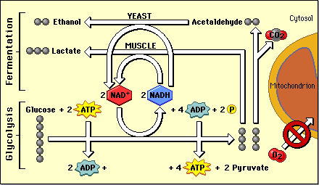

Based off of the above diagram, what are the two possible products of the different kinds of fermentation? _______________________ & ____________________

There are two types of fermentation. Both types of fermentation regenerate oxidized NAD⁺, which is necessary for glycolysis and consequently the continued production of ATP by that pathway.
The net energy gain in fermentation is 2 ATP molecules/glucose molecule. In both lactic acid and alcoholic fermentation, all the NADH produced in glycolysis is consumed in fermentation, so there is no net NADH production, and no NADH to enter the ETC and form more ATP.

Click on the “Review” section at the top right hand corner of the page. Firstly, review Lactic Acid fermentation.

Why is it beneficial that the pyruvate which is produced in glycolysis is reduced to form NAD⁺?

What is another name for lactic acid? _________________

Secondly, review Alcoholic fermentation. The pyruvate from glycolysis loses one _____________ to form carbon dioxide. The resulting two carbon molecule is reduced by _____________ to form ethyl alcohol or ________________. What happens to the newly oxidized NAD⁺ molecules?
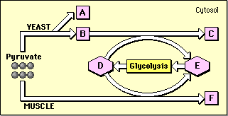
What is the name and function of the missing
components in the diagram?

A.

B.

C.

D.

E.

F.

Glucose and Energy
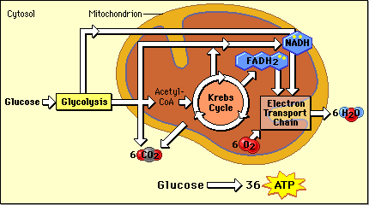
The chemical energy stored in glucose generates far more ATP in aerobic respiration than in respiration without oxygen (glycolysis and fermentation).

Each molecule of glucose can generate 36-38 molecules of ATP in aerobic respiration but only 2 ATP molecules in respiration without oxygen (through glycolysis and fermentation).

Click on the “Review” section at the top right corner of the page. Go through the stages and determine the energy yield in each section of respiration.
What is the energy yield of glycolysis?

What is the energy yield from a pyruvate molecule?

What is the energy yield from the Kreb’s cycle?

What is the energy yield from the ETC and chemiosmosis?

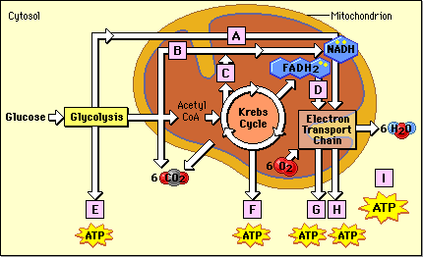
What is the number of ATP produced
in each of the following stages?

A.

B.

C.

D.

E.

F.

G.

H.

I.

Self-Quiz

1. In aerobic respiration carbohydrates are ultimately broken down into:
A. acetyl Co-A
B. CO₂
C. O₂
D. H₂O
E. heat

2. Most ATP in eukaryotic cells is produced in the
A. mitochondria
B. nucleus
C. cytoplasm
D. rough endoplasmic reticulum
E. peroxisome

3. Most ATP produced in aerobic respiration occurs in the process of:
A. glycolysis
B. the formation of acetyl-CoA
C. the Krebs cycle
D. chemiosmosis
E. substrate-level phosphorylation

4. In aerobic respiration, the energy in 1 molecule of glucose is capable of producing how many ATP molecules?
A. 2 molecules
B. 38 molecules
C. 22 molecules
D. 6 molecules

5. Products of glycolysis include:
A. pyruvate
B. ATP
C. NADH
D. two of the above
E. all of the above

6. In glycolysis the most reduced compound formed is:
A. pyruvate
B. NAD⁺
C. lactate
D. O₂
E. H₂O
7. In glycolysis, the activation of glucose is accomplished by:
A. NADH
B. coenzyme A
C. ATP
D. CO₂
E. O₂

8. Products of the Kreb’s cycle include:
A. carbon dioxide
B. NADH
C. FADH₂
D. two of the above
E. all of the above

9. The final electron acceptors in aerobic respiration is:
A. pyruvate
B. carbon dioxide
C. oxygen
D. water
E. NAD⁺

10. In the presence of oxygen, all cells synthesize ATP via the process of glycolysis. Many cells also can metabolize pyruvate if oxygen is not present, via the process of
A. fermentation
B. aerobic respiration
C. oxidative phosphorylation
D. electron transport
E. photophosphorylation

11. The net result of the breakdown of glucose in glycolysis and fermentation is the production of:
A. 38 ATP
B. 36 ATP
C. 2 ATP
D. NADH
E. NADH, FADH₂ and ATP

12. Which stage of aerobic respiration requires ATP?
A. glycolysis
B. Kreb’s cycle
C. electron transport chain
D. fermentation
E. none of the above
13. Which stage of aerobic respiration requires CO₂?
A. glycolysis
B. Kreb’s cycle
C. electron transport chain
D. fermentation
E. none of the above

14. Which stage of aerobic respiration produces ATP and NADH and releases CO₂?
A. glycolysis
B. Kreb’s cycle
C. electron transport chain
D. fermentation
E. none of the above

15. The high concentration of protons in the inner mitochondrial space relative to the mitochondrial matrix represents:
A. magnetic energy
B. kinetic energy
C. potential energy
D. photonic energy
E. none of the above

16. As protons flow through the _______, energy is released and exploited to combine ADP and inorganic phosphates to form ATP.
A. electron transport chain
B. outer mitochondrial membrane
C. cytochrome oxidase
D. ATP synthase
E. NADH

